IEEE IES Young Professionals & Student Activity Committee
Program for the Conferences ver20190528
IEEE Industrial Electronic Society
IEEE IES Student and Young Professionals Activity Committee (SYP-AC)
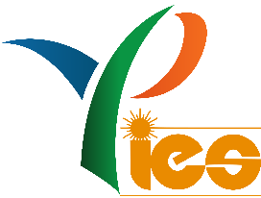
The outstanding support for IEEE IES conferences and their participants! We offer:
- The IES Young Professionals & Student Paper Assistance (IES-SYPA). Please note that Young Professionals (also, doctors and young professors are included) could obtain the USD 2000 assistance to attend the conference.

- The Young Professionals & Student Tutorials and Industry Links – excellent place were invited speakers will share their experience with all conference attendees. IES SYP-AC selects the speakers and cover their travel expenses!

- The Young Professionals & Student Forum - where young authors will share their knowledge witch all conference attendees. IEEE IES reserved USD 3000 for recognition of the best papers and presentations.

- Young Professionals & Student Party. Where IEEE IES Officers including the IES President and well know researchers exchange their experiences with younger IES members and future members in relaxing atmosphere. IEEE IES reserved USD 4000 (for a conference chairperson support) to sponsor this event. In case of large number of young attendees, the support would be even increased!

- IES Young Professionals & Student Paper Assistance (IES-SYPA) 3 minute speeches with 3-minute videos to promote projects of awarded authors. IEEE IES reserved for this more than USD 100 000 annually!

- Diplomas ceremony of the IES-SYPA during the Gala Diner to promote young researcher and conference!

Join IEEE IES and enjoy our outstanding scientific conferences! We support you and your industry education.
Visit us at http://www.ieee-ies.org/ .
Organizers

Prof. Milos Manic <mmanic@vcu.edu>;
Prof. Marek Jasinski (marek.jasinski@ieee.org);
Prof. Dmitri Vinnikov (dmitri.vinnikov@ieee.org);
Dr Christian Rojas (christian.rojas@usm.cl);
Dr Marek Turzynski (marek.turzynski@pg.edu.pl);
Dr Hani Vahedi (hani.vahedi@ieee.org);
Dr Adam Milczarek (adam.milczarek@ee.pw.edu.pl);
Dr Hong Li (hli@bjtu.edu.cn );
Dr Sertac Bayhan (sertac.bayhan@qatar.tamu.edu);
Prof. Aleksander Malinowski (olekmali@bradley.edu)
Prof. Andrés-IES-A. Nogueiras Meléndez (aaugusto_ies@gmx.com)

Chair of IEEE IES Students & Young Professionals Activity Committee
Marek Jasinski

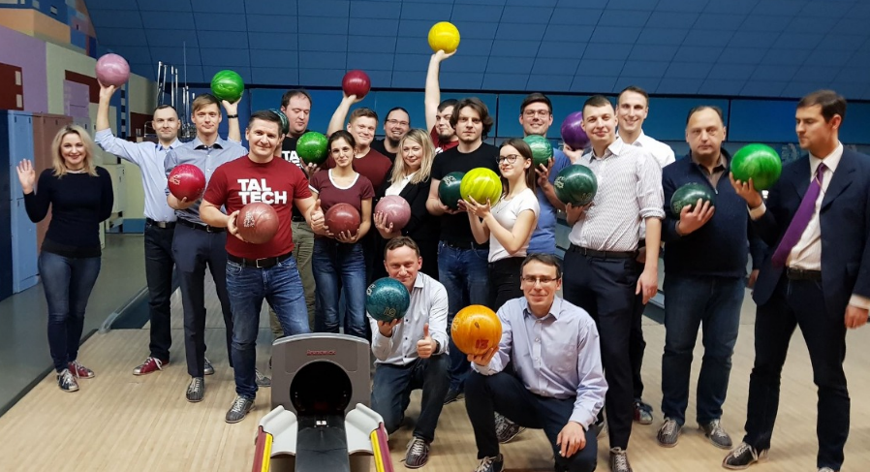
IEEE IES Young Professionals & Student (YPS) cooperation inside Society and outside of the Society; IES YPS party at bowling.

