IEEE IES Young Professionals & Student Activity Committee (SYP-AC)
IEEE Industrial Electronic Society
How to apply for:
The IEEE IES S&YP Paper Assistance (IES-SYPA)
at selected IEEE IES Conferences (ver20190214)
The IEEE IES Web & Information Committee (WIC) with the Young Professionals (YP) & Student (S) Activity Committee (SYP-AC) would like to introduce a draft of manual how to apply for the IEEE IES Young Professionals & Student Paper Assistance (IES-SYPA) at selected IEEE IES Conferences.

The offer is focused, but not limited to the IEEE Young Professionals & Student (SYP). Our support can indirectly help Supervisors, Mentors and Professors that would like to promote interesting work of their younger colleagues as well as IEEE IES conferences to attract more attendees. Mentors can support their mentee not only by co-authoring scientific papers but also by advising them to join the IEEE IES to be able to attend the IEEE IES conferences.

- The applications for the IES-SYPA are collected by the Manuscript Submission System (MSS) of the IEEE IES (Fig. 1) [1]. At least one co-Author should be IEEE, IES, Young Professional or Student Member.

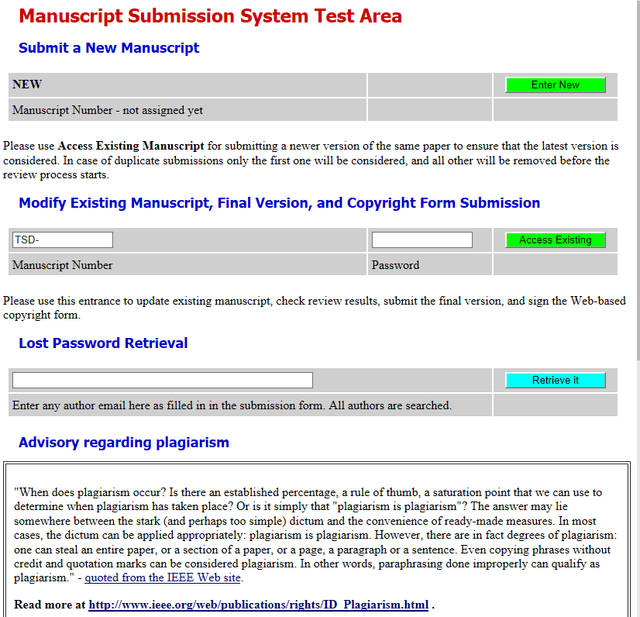
Figure 1 The Manuscript Submission System (MSS) of the IEEE IES [1] (Attention: based on TEST example!).
- During submission, the applicant should check the Student box in Fig.2. It should be noted that also the YP should check this box to see the application button in next section.
- The Applicant for the IES-SYPA has to be the IEEE IES Student and/or YP active member. In this case, when final version and copyright form of the manuscript is submitted, the button for application shall be activated (Fig.2b).
- The deadline for the IES-SYPA application is two weeks after paper acceptance announcement [2].
- Applicants who are selected for the IEEE IES-SYPA should post their 3 minutes’ video on the associated IEEE IES Collabratec, Facebook event page and the IEEE IES YouTube channel [3], [4].
- The selected students of the IEEE IES-SYPA must follow the guidelines according to the video preparation and publications [5].
- The selected students of the IEEE IES-SYPA must present the 3 minutes speech and the prepared video at the conference by themselves during the IEEE IES SYP 3-minutes session.

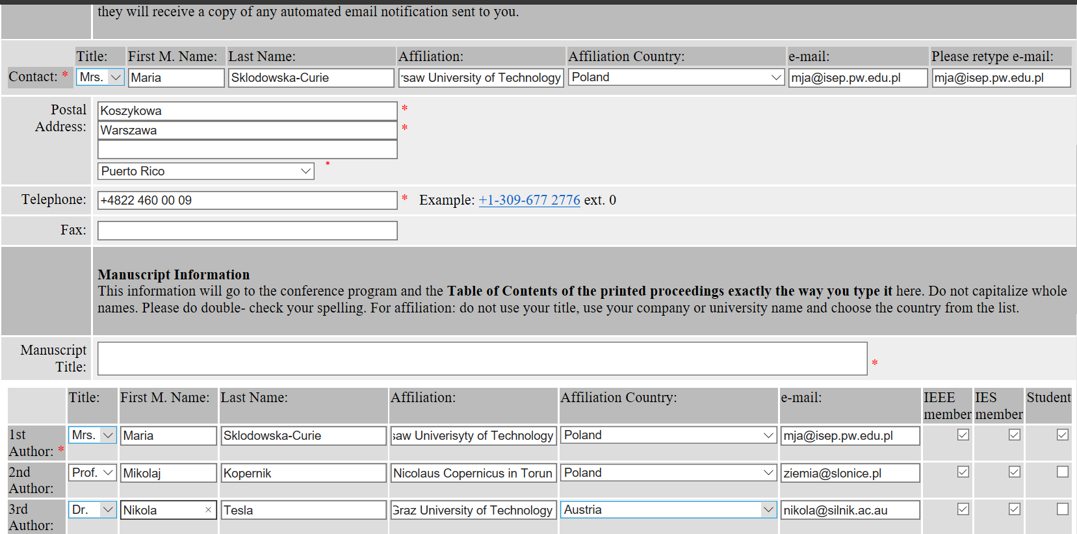
IEEE IES SYP Members
b) Then after the successfully reviews:
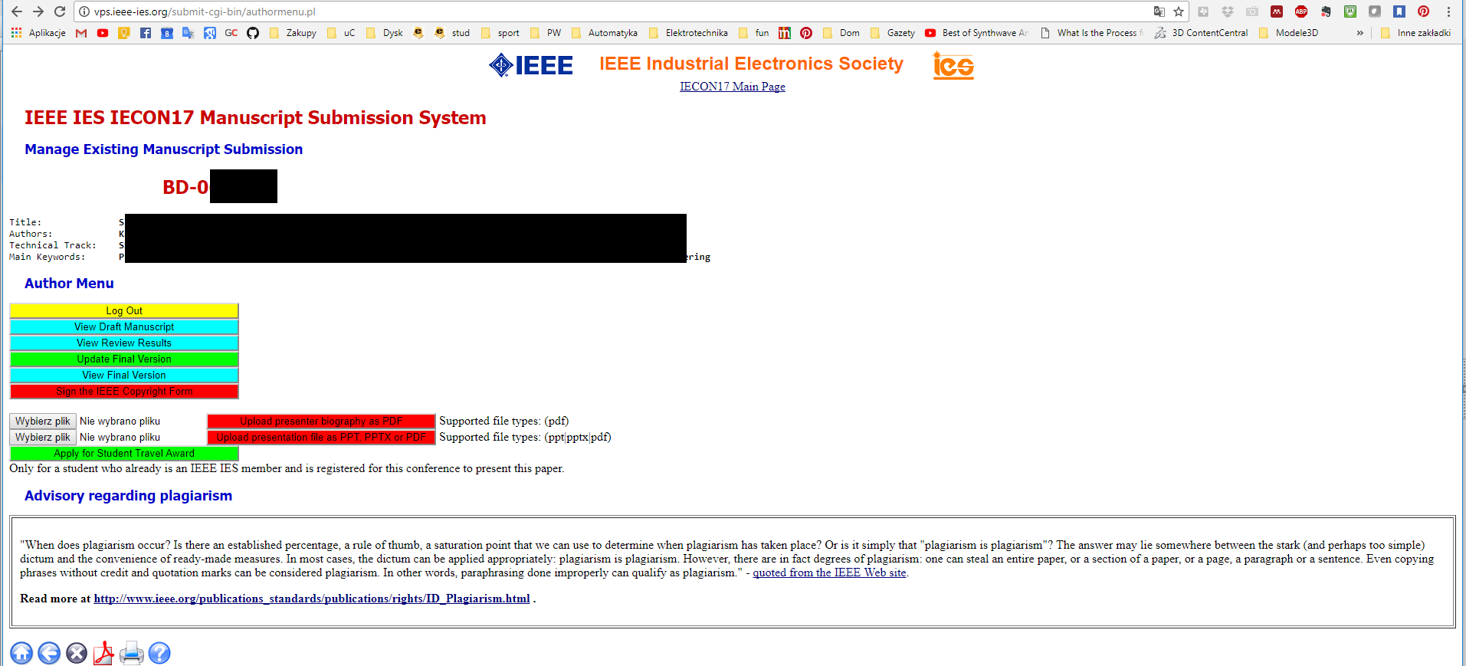
IEEE IES Young Professionals & Student Members
Figure 2 The possibility for the IES-SYPA application is available if an Author is the IEEE IES Young Professionals &/or active member. In this case, when conference registration and final version of the manuscript is submitted, the button for application shall be activated.
References:
- http://vps.ieee-ies.org/submit/
- http://www.ieee-ies.org/students/travel
- https://www.facebook.com/IndustrialElectronicsSociety/
- https://www.youtube.com/channel/UCKg8GNii0Q-ieXE56AXosGg .
- http://www.ieee-ies.org/students/guidelines
On behalf of the IEEE IES:
The VP-Membership Activities Yousef Ibrahim,
The VP-Conferences Activities Juan J. Rodriguez-Andina,
The President Xinghuo Yu, the President Elect Terry Martin, and Treasurer Milos Manic,

Sincerely yours,
The Chair of the WIC, Andres A. Nogueiras Melendez, and Aleksander Malinowski, and
Chair of the IEEE IES Young Professionals & Student Activity Committee
Marek Jasinski

